

Submitted in part fulfilment for the degree of MSc Computer Science

Using Machine Learning & Statistical Analysis to Predict UK Local Election Results
Ian Milburn

Click or tap to enter a date.

Supervisor: Click or tap here to enter text.

Acknowledgements
Click or tap here to enter text.

Statement of Ethics
This research project was conducted in accordance with the University of York’s Code of Practice on Research Integrity and Ethics Guidelines for Computer Science. Prior to data collection and analysis, formal ethical review was undertaken, and an ethics self-assessment form was completed and signed by the project supervisor (Dr Tina Baker). A copy of the signed ethical approval documentation is included in the project artefact submission directory.

The study relies exclusively on the secondary analysis of publicly available, aggregated datasets, including anonymised demographic baselines from the Office for National Statistics (ONS) Census, official election returns published by UK local authorities and Democracy Club, and aggregate national polling figures. No primary human participant recruitment, interventions, or direct surveys were conducted by the author. All data handling and processing adhered strictly to the Data Protection Act 2018 and the UK General Data Protection Regulation (UK GDPR), ensuring that all spatial and electoral attributes remain fully aggregated at the Output Area and electoral ward levels without risk of individual re-identification.

Executive summary

1. Context & Research Problem
Most election forecasting systems rely on national-level surveys representative of parliamentary constituencies but unrepresentative of council divisions, leaving UK wards as sub-national "data deserts". Downscaling national samples introduces a severe Ecological Fallacy and cell sparsity when local dynamics diverge from national swings. Local authorities require accurate forecasts for service planning, while political parties need spatial intelligence for campaign logistics. This dissertation evaluates whether non-linear machine learning ensembles (Random Forest and XGBoost) can outperform traditional linear statistical models in predicting continuous candidate vote shares across English local council wards

2. Proposed Solution & Methodology
An integrated, data-driven forecasting pipeline was constructed using a relational MySQL database uniting Office for National Statistics (ONS) Census Output Area metrics, 6,008 historical candidate returns spanning 2016–2026, and time-variant national polling vectors. The feature engineering pipeline derived four key tactical vectors to model First Past the Post (FPTP) voter coordination: continuous vote share change ($diff_vote_shr$), top-two margins ($top_2$), an ideological spectrum index ($left_right$), and a 15% wasted-vote compression flag ($wasted_vote$). The matrix was evaluated across XGBoost and Random Forest frameworks against a control Linear Regression baseline using $R^{2}$ and $RMSE$ loss metrics. TreeSHAP attributions and the GeoVisX spatial framework were integrated to visually audit decision pathways across geographic ward boundaries.

3. Key Findings & Empirical Results
However, hypothesis $H_{2}$ is formally accepted. Tactical proxies—specifically the wasted_vote flag (+4.03 mean absolute SHAP impact)—proved to be the third most influential feature group globally. While linear models fit smooth historical trends efficiently, non-linear ensembles remain essential for capturing step-function voter coordination ($top_20$) in marginal seats.

4. Practical Impact & Future Work
This framework allows local authorities to anticipate council administration shifts for smooth governance transitions and budget planning. Political parties can leverage localized $top_2$ margins and wasted_vote flags to optimize campaign resource allocation and doorstep canvassing. Future extensions include integrating Natural Language Processing (NLP) for real-time local news sentiment, expanding to multi-member devolved voting systems (STV/AMS), and deploying Bayesian optimization (Optuna) for automated hyperparameter tuning as new returns are ingested.

Table of Contents
1. Executive summary 4
1. Context & Research Problem 4
2. Proposed Solution & Methodology 4
3. Key Findings & Empirical Results 4
4. Practical Impact & Future Work 5
2. Introduction 11
1. Proposed Solution 11
2. Questions & Hypotheses 12
3. Research Objectives 12
4. Scope, Limitations, and Outline 13
3. Literature Review 14
4. Methodology 17
1. Philosophical Positioning 17
2. Methodological Choice and Strategy 17
3. Data Collection and Preprocessing 18
4. Engineering Tactical and Surge Vectors 19
5. SQL Data Infrastructure & Pipeline Architecture 20
6. Data Lifecycle & Relational Extraction (SQL to Flat Feature Matrix) 21
7. Technical Stack & Reproducibility Specifications 22
8. Predictive Model Architecture & Training Strategy 23
9. Evaluation Framework and Local Explainability 23
5. Results and Findings 25
1. Introduction & Predictive Pipeline Summary 25
2. Global Algorithmic Performance & Predictive Baseline 25
3. Global Feature Importance Analysis 26
4. Feature Impact Heterogeneity & Nonlinear Dynamics (SHAP Summary Plot) 27
5. Spatial Explainability & Ward-Level Micro-Lookup (GeoVisX Integration) 28
6. Conclusion 31
1. Synthesis of Findings & Research Question Resolution 31
2. Theoretical & Methodological Contributions 31
3. Practical Implications & Real-World Impact 32
4. Critical Limitations of the Study 32
5. Future Research Directions 32
7. Bibliography 34

List of Figures

Figure 1: SHAP Global Feature Importance Analysis Bar Chart 29
Figure 2: SHAP Top_2 Feature Scaling & Interaction 30
Figure 3: wasted_vote 31
Figure 4: candidate_personal_historical_mean 32

List of Tables

Table 1. Feature Description and Data Sources 22

Introduction
UK national general elections, and by-elections, are extensively polled and well analysed. UK local council elections have been left as “data deserts.” Most modern forecasting systems obtain their information from national-level surveys and focus groups [1],[2]. The data gathered from the national-level sources are representative of national government constituencies [2], but are unrepresentative for local council wards, preventing local-level forecasting. Local councils have the tasks of managing significant budgets and shape critical local policies while implementing the foundations of programs set by the national government. These programs can range from housing, education, transport infrastructure, and waste collection, which can have an impact on the electorate’s quality of life. Local political parties also must prepare for elections, including selecting candidates, developing local manifestos, arranging budgets, and arranging action days. Being able to forecast local election results and understanding voting patterns will allow councils to appreciate the will of the electorate and develop long term plans efficiently. This knowledge will also allow local parties to campaign efficiently and effectively.
Today’s polling methodologies heavily rely on analysts aggregating national political survey results down to lower geographical levels to predict local behaviour. However, as established in epidemiological and social science methodologies, forcing macro-level group aggregates to explain individual behavioural outputs invite a severe Ecological Fallacy [2]. This causes a considerable number of predictive errors where local dynamics diverge from the national swing. This study will show how the demographic and socioeconomic factors within the wards of UK councils and national polls can be used to forecast the results of local elections. The main unit of analysis will be the individual council wards which contain all the granular data about the council’s population.

Proposed Solution
To bridge the sub-national data desert, this project introduces an integrated machine learning pipeline engineered to ingest high-dimensional tabular features. This study utilizes non-linear ensemble frameworks—specifically Random Forest and XGBoost—to process complex socio-economic, demographic, and political interactions at the granular scale of individual local wards. Rather than treating electoral variations as uniform across space, this solution models localized thresholds directly from Office for National Statistics (ONS) Census data and historical returns. The model will also be adapted to account for voter rationality, strategic alignment, and anti-incumbency surges. Crucially, to preserve academic transparency and audit the traditional "black-box" nature of advanced algorithms, the pipeline incorporates SHAP (SHapley Additive exPlanations) values and the GeoVisX framework, projecting mathematical feature attributions into explicit spatial boundaries to map regional exceptions and structural thresholds Research.

Questions & Hypotheses
This study is structured around a primary, overarching research question:
- To what extent can non-linear tree-based machine learning algorithms outperform traditional, linear statistical models in predicting UK ward-level local election outcomes?
To evaluate this question empirically, the following formal statistical hypothesis is established:
- $H_{1}$: Non-linear tree-based ensemble algorithms (Random Forest and XGBoost) will yield a significantly lower Root Mean Squared Error (RMSE) than a traditional linear Logistic Regression baseline when forecasting continuous candidate vote shares in local ward elections.
- $H_{2}$: The addition of localized structural proxies (such as historical top two margins and ideological bloc indices) will yield a statistically significant reduction in continuous prediction error compared to a purely demographic-centric baseline feature matrix.

These hypothesises are methodologically justified by contemporary data science literature, which demonstrates that ensemble models possess unique inductive biases that make them uniquely suited for capturing the irregular statistical margins and non-linear cleavages inherent to heterogeneous, tabular demographic grids.

Research Objectives
To address the primary research question, test statistical hypotheses $H_{1}$ and $H_{2}$, and deliver a transparent predictive framework, the project is bound to three actionable objectives:
- Data Infrastructure Construction: To construct a unified, SQL-relational dataset by integrating disparate public data streams, including ONS Census metrics at the Output Area scale, historical local authority records, and time-variant national polling vectors.
- Algorithmic Benchmarking: To train, optimize, and evaluate multiple supervised learning models (Random Forest and XGBoost), utilizing a strict 80/20 data partition and a 5-fold cross-validation protocol to benchmark their predictive accuracy against a Logistic Regression control group.
- Explainable AI (XAI) Auditing: To apply a post-hoc SHAP and GeoVisX pipeline to quantify the relative importance of hyper-local socio-economic factors versus national polling trends, ensuring the model's predictive pathways are auditable and interpretable.

Scope, Limitations, and Outline
The spatial and temporal scope of this study is strictly confined to Upper Tier local authorities in England across a ten-year cycle spanning 2016 to 2026. This boundary encompasses a diverse combination of County Councils and Unitary Authorities, explicitly capturing standard scheduled local elections, delayed cycles—such as the deferred Norfolk County Council elections—and intervening sub-national by-elections. An acknowledged mathematical limitation of this design is the inherent inability of tree-based ensemble models to extrapolate values outside the range of their historical training data; if an unprecedented, historic swing occurs that breaks all numerical boundaries within the 2016–2026 dataset, the model will inherently incorrectly-predict its magnitude.
The remaining structure of this dissertation is partitioned into five sequential chapters: Chapter 2 (Literature Review) provides a critical audit of current forecasting methods and identifies the local spatial research gap; Chapter 3 (Methodology) grounds the positivist philosophy, database schema, and model training strategies; Chapter 4 (Design and Implementation) documents the execution of the Python codebase; Chapter 5 (Evaluation) details the continuous $RMSE$ results and GeoVisX spatial visualizations; and Chapter 6 (Conclusions) synthesizes the findings and offers an outlook for future geospatial AI applications.

Literature Review
The use of polling methods to predict the results of UK general elections and by-elections is a well-established field in modern political science [1],[3],[4],[5]. Most of the data that is used today is collected through multiple national level data surveys, focus groups, and social media platforms like X (formally known as Twitter) [1],[5],[6]. This data can then be analysed and aggregated down to constituency level results [3],[7]. When the results are aggregated down to the wards used in local government elections there is an Ecological Fallacy [2] due to the incorrect assumptions that national trends apply uniformly to decisions that are made in local-level wards. This lowers the accuracy of local level polling and election forecasting [2] [3].
This study establishes the theoretical and empirical justification for the proposed Machine Learning (ML) pipeline by critically auditing the current forecasting frameworks. It is partitioned into three core investigative phases: an examination of the predictive limitations inherent in traditional qualitative [1] and linear statistical models when compared to tree-based ensembles [3], [4]; a critical review of data integration strategies engineered to unify disparate census grids and national polls [3], [5]; and an identification of the spatial research gap that emerges when attempting to operationalize these methodologies within UK local council divisions.
Most of today’s polling methods, such as qualitative research, traditional linear statistical methods that use data collected from social media platforms [1] [5] [6], regional or national focus groups [1], national level surveys [4] [7]. This data can be efficient when analysing the public mood at the national level of politics.
Data that has been collected through focus groups that involve people from across the country or within certain regions [1], can be efficient for capturing how, and why, people feel about politicians, political parties, and political events [1]. Due to costs, lack of public interest in politics [20], and the requirements of GDPR [8], it can be hard to find enough participants to create focus groups for each council ward. The low levels of participation and errors in sentimental analysis can result in there being too small an amount of data or inaccurate to make accurate forecasts [2].
Social media platforms such as X and Facebook [4], [5], have also been used by analysts for case studies into public mood and reactions [4], [5]. The case studies evaluate the reactions and comments made by the audience about posts made by authenticated candidates, politicians, or political parties [4], [5], [9]. Using social media also has several disadvantages, in that it relies on political events [4], [5], the candidate and constituents being active on social media, and local knowledge of candidates [21]. Social media case studies can work well in national and regional politics because candidates are more likely to be well known and national and regional events can be common knowledge due to the national media [20]. Also, social media platforms are populated by non-geographic users, meaning the resulting data lacks the geospatial precision required to represent an individual ward. Further, the landscape is becoming more populated by AI bots to raise the number of interactions. This is causing platforms to become more like echo chambers [11]. The demographics of the people using social media is vastly different to that of the general population, this includes – age, gender, education, and political attitudes [10]. This prevents the results of studies into the pollical views of the population being representative.
Most of today’s polling methods, like Election fundamentals models and Multilevel Regression and Poststratification (MRP) methods, use data from national-level surveys [3], [7]. The data constitutes the primary baseline for tracking nationwide partisan intent. These datasets record individual-level categorical profile characteristics—specifically individual age, race, and educational qualifications—alongside high-level regional indicators and area-level covariates [6].
A large amount of data used in political science is collected through the national census from the Office of National Statistics (ONS) [3]. The national census provides substantial amounts of data about the demographics and socio economics of the country’s population, including age distributions, qualifications levels, housing tenures, and localised deprivation indices [3]. The census provides complete spatial saturation across every neighbourhood building brick (output area) in England and Wales, leaving no geographic blind spots. The census has the disadvantage of the fact that it is 100% static and stands for a frozen snapshot taken once every decade [3]. This means that it cannot capture real-time political drifts, campaign effects, or time-variant public moods on its own.
It is necessary to examine how alternative methodologies process and transform their data streams. Data collected through qualitative techniques like focus groups, or case studies on social media is fundamentally unstructured, requiring transformation using sentimental analysis [1], [5], [6] or evaluation by a qualitative researcher. The sentimental value of the comments and reactions can be used to decide the public mood about candidates and parties and how they manage events, and their levels of support [4], [5], [9]. Data that has been quantified through sentimental analysis or is collected through the national census or national surveys is already collected in quantitative form [12], allowing for the data to be stored in databases and processed through Machine Learning algorithms, such as Univariate, Random Forest, and Select or mathematical evaluation frameworks like RMSE/SHAP [13].
In contrast, traditional statistical downscaling [6], dominated by MRP, processes data by breaking national survey samples into discrete, multi-dimensional demographic cells (e.g., cross-tabulating age cohorts by education levels) [6]. Along with a geographical indicator these can be aggregated down using the areas demographics to decide the area’s population’s opinion of certain political parties [3], [7]. While this linear hierarchical processing achieves robust predictive accuracy at coarser geographic scales, such as parliamentary constituencies, its internal architecture fails at the micro-geographic ward level [3], [7]. When forced into thousands of tiny local divisions, the processing grid suffers from catastrophic cell sparsity where the sample size within individual demographic categories drops to zero. This architectural failure confirms that traditional downscaling workflows are structurally insufficient for local political modelling [6].
Most of these models are based on General Elections and Sub-National elections [3],[4],[5]. Local-level elections are much harder to predict due to the enormous number of wards, varying number of councillors per ward, and a lack of funding. Consequently local-level elections are extremely under researched compared to national-level elections, due to the national bias [3].
Due to the inability to confirm the geographical location of the audience, the number of automated bots, demographic differences [10], [11], and lack of local events and media coverage, models that use social media are flawed[10]. The traditional statistical models, such as Poll aggregation models, Poll aggregation models[2] and qualitative methods like focus groups [1] can lack the local data to pin to individual wards, and models such as the MRP [3] can be too computationally expensive, and its mathematical architecture does not contain the granularity required to make forecasts at the local level of politics [2]. There remains a scarcity of literature that applies into how machine learning can be applied directly to census data, national polls, and historical election results for UK local wards.
This data sparsity makes it a necessity to use an alternative machine learning approach [1] [3] to forecast local level politics [3]. This research aims to bridge the gap by using machine learning systems, such as Random Forest or XGBoost on local-level data like the census and local and national political trends to predict election results for individual local wards.

Methodology

Philosophical Positioning
Following standard data science paradigms outlined by researchers such as Saunders et al.[15], this project adopts a positivist research philosophy anchored in an objectivist ontology. Positivism asserts that social reality is objective, real, and governed by underlying structural laws that exist independently of the researcher's subjective perception [15]. In political forecasting, an objectivist ontology posits that aggregate electoral outputs are not purely erratic or subjective individual decisions; rather, they reflect measurable sociopolitical cleavages, spatial demographics, localized economics, and historical voting returns [13] that are independent of the observer. Because voter intent leaves concrete empirical footprints—such as census results [13] distributions, educational attainment rates, and past candidate vote shares—there exists a single, quantifiable reality of municipal electoral behaviour that can be captured and modelled mathematically
This philosophical positioning directly informs the study's deductive research approach. Rather than inductively constructing new political theories through real-time qualitative observation or soft sentiment interpretation, the project begins with existing theoretical frameworks—namely, that socio-economic status and structural cleavages predictably drive political alignment [20]. These theoretical models are translated into explicit statistical hypotheses ($H_{1}$and $H_{2}$) then subjects them to empirical testing using secondary data. This design means the project does not involve developing new theories by interpretively observing voters in real-time. Therefore, to remain consistent with this positivist stance, the research follows a deductive research approach, evaluating whether advanced computational techniques hold true against established sociopolitical principles.

Methodological Choice and Strategy
To operate on this deductive, positivist framework, the research adopts a mono-method quantitative research design. In contrast to qualitative strategies (such as focus groups or social media text scraping) that rely on soft sentiment parsing or inductive text interpretations, this study prioritizes structured, high-dimensional tabular data arrays.
Due to Britian’s plural First Past the Post (FPTP) voting system many supporters of smaller parties tend to vote for the most acceptable major party, rather than give a “wasted vote” to their preferred candidate [26] to prevent the least preferred candidate from winning. This study will counter this by modelling contextual district rules based on the past election results [26], rather than assuming that the voters act in a demographic vacuum.
Qualitative approaches, like focus groups and case studies have the ability to analyse the sentimental reasons for why people may vote for certain candidates for an election. This can help forecasters to predict results by comparing the results in the ward with the national public mood [1], [4], [5], [9]. This approach will be unsuitable for this type of study because it will require an extremely large level of local participation [1] and strict following of the GDPR constraints [8]. This have high costs and participation challenges when the process is scaled up across thousands of local wards [1].
As this study requires an accurate study of voter behaviour within each ward, methods such as social media scraping are likely to be unsuitable. This is because the social media users are not confined to individual wards and often contains content from users that do not state their location [9], [10], preventing a study of the ward’s voters. Social media content also contains a lot of noise from AI bots[10], [11] and the demographics of the users does not represent the demographics of the general population[10], creating echo chambers [11]. This will prevent the study from providing results that are representative of the population.
Studying individual wards creates a high level of data sparsity [2]. This makes the challenge of downscaling standard models like the MRP method extremely computational expensive, and inaccurate when forced down to the local level [3], [6], [7]. This prevents it from providing suitable results for this study.

Data Collection and Preprocessing
The primary stage of this pipeline involves constructing a robust, unified relational dataset from disparate public repositories. Socio-economic baselines are extracted from the 2011 and 2021 UK National Censuses via the Office for National Statistics (ONS) Nomis platform [4], like the ONS website (Nomis [16]). Due to the fluidity of ward boundaries, the census data has been downloaded in terms of the census output areas (OAs). This has allowed for the data to adapt to the frequent changes in the size and layout of the wards made by the Electoral Boundary Commission, and the project to continue to work after future changes to council structures. The use of OAs also allows the data to be dissolved to show the results at various geographical levels, such as OA, wards, councils, or national. ONS electoral lookup files for the new boundaries were used to map all the output areas to the correct ward for each election cycle and projecting spatial layers to a unified Coordinate Reference System for GeoVisX spatial rendering.
The geographical data, such as council code, council name, ward code, ward name, output area code, and look up files, can be downloaded from the ONS Geography Portal [19]. These files will allow the OAs and the census data to be assigned to the relevant ward or council and the election results. Data will be downloaded as Shape, geoJSON, and csv files. They will provide geographic coordinates (longitude, latitude) were associated with each county to enable geospatial modelling and visualization. For temporal consistency, variables were harmonized to constant definitions across election years using standardized preprocessing workflows [13].
The electoral history of each ward and candidate was obtained through UK council websites Data from these sources are heavily scrutinised and updated regularly after each election.
All the data from the census and election results were thoroughly cleaned by removing spaces and transforming all to lowercase. As all the results are collected from multiple sources there are several variations in the naming of political parties and wards (e.g. “Gaywood North & Central” or “Gaywood North and Central ED” , "Lab", and "Labour Party”). Therefore, several mapping variations were used to ensure that all names were converted to a standard format.
From each set of results each candidate’s vote share was calculated, which serves as the primary dependent target variable. This standardises the data, avoiding any issues caused by various levels turnout at diverse types of elections, and population size. Other variables such as incumbent councillor were created using the councils’ electoral history. A new variable was created to flag when the election was uncontested , which can cause issues for variables such as vote share. To account for temporal political shifts, dynamic national polling vectors from peer-reviewed repositories, including YouGov and the UK Data Service, are fused to the matrix, functioning as a proxy for the shifting "national winds" in UK politics.

Engineering Tactical and Surge Vectors
To account for tactical voting and populist protest votes, six variables will be engineered from the election results data:
- Gain in vote Share (diff_vote_shr): Engineered by subtracting a candidate’s vote share in one election cycle from the preceding one [26].
- Top 2 Margin (top_2): Calculating the difference between forecasted vote share of the top two parties [26].
- Left/Right Index (left_right): Aggregating ideological blocs to simulate strategic shifting between minor and major parties based on public perception of parties and the political spectrum [25] [26].
- Wasted Vote (wasted_vote): Implementing a 15% threshold flag to simulate the "tactical squeeze" of uncompetitive candidates [26].
- The candidate is the incumbent councillor (is_incumbent_cllr): Engineered from election results by determining if the councillor is already elected in the same council.
- The election was uncontested (is_uncontested): Engineered from election results checking if the number of candidates standing in the same ward during that election.
The complete feature matrix is detailed below:
Variable Name | Type | Description | Source
wd_code | String | Ward ID code | ONS Geography Portal
cc_code | String | Council ID code | ONS Geography Portal
ward_pop | Integer | Population of the ward [13] | UK Census
vote_shr | Float  (Continuous) | Vote Share [13] | Local Election Results
diff_vote_shr | Float  (Continuous) | Change in vote share from last election [26] | Local Election Results
pct _own_hme | Float  (percentage) | Percentage of population who own their home [18] | UK Census
pct_rent | Float  (percentage) | Percentage of population who rent their home | UK Census
pct_age_18_29 | Float  (percentage) | Percentage of population aged eighteen to twenty-nine [13] | UK Census
pct_age_30_65 | Float  (percentage) | Percentage of population aged thirty to sixty-five [13] | UK Census
pct_age_over_65 | Float  (percentage) | Percentage of population aged over sixty-five [13] | UK Census
pct_wk_class | Float  (percentage) | Percentage of population in Working Social Class [18] | UK Census
pct_mid_class | Float  (percentage) | Percentage of population in Middle Social Class [18] | UK Census
pct_student | Float  (percentage) | Percentage of population who are students | UK Census
pct_bch | Float  (percentage) | Percentage of population with a bachelor’s degree or higher [13],[18] | UK Census
pop_den | Float (Continuous) | Population Density [13] | UK Census
pct_female | Float  (percentage) | Percentage of population that is female [13] | UK Census
pct_male | Float  (percentage) | Percentage of population that is male [13] | UK Census
pct_fb | Float  (percentage) | Percentage of foreign-born population [13] | UK Census
pct_poll | Float  (percentage) | Real-time national political party polling rating | Polling Company Websites
party_name | String | Registered name of the political party | Local Election Results
cand_name | String | Registered name of the individual candidate | Local Election Results
year_results | Integer | Calendar year of the specific local election cycle | Local Election Results
date_results | date | Date election was held | Local Election Results
top_2 | Float  (Continuous) | Distance between the first and second-place parties [26] | Local Election Results
left_right | Integer | Definition between left- and right-wing parties [25] [26] | YouGov [25]
wasted_vote | Integer | Will the party be considered as a wasted vote (finished third or less than 15%) [26] | Local Election Results
is_uncontested | Integer | Show if this is the only candidate standing in this election | Local Election Results
is_incumbent_cllr | Integer | Shows if this candidate is already elected in this council | Local Election Results

Table 1. Feature Description and Data Sources

SQL Data Infrastructure & Pipeline Architecture
The data about the structure of the wards was obtained as CSV files of the Output Areas from the National Census and lookup tables from the ONS website. These were then stored in a database spread across five tables: census, county_codes, electoral_wards, and geographic_lookup. The census data was stored in the census table along with the output area id code and census year to identify the location and time the data came from. The Ward ID codes and Ward names, and county codes are stored in the electoral_wards table. The data from the lookup tables is stored in the geographic_lookup containing data about the year the data applies to, the output areas code, the ward code and the county code.
After being obtained from council websites or other public sources, election results are stored in csv files that hold the candidates name, party name, election date, ward code, vote share, county code, number of seats available, who won, and number of votes. This file was then moved into the SQL database in two tables election_results, candidates. The candidates table contains the candidate’s id, the candidates name and the party registered with the candidate. The election results table stores the candidates’ id, election date, ward code, vote share, county code, number of seats available, who won, and number of votes. Once obtained from national polling company sites, each party’s national polling number at the time of each election is stored in the election_results table.

Data Lifecycle & Relational Extraction (SQL to Flat Feature Matrix)
An automated extraction and feature engineering workflow using SQLAlchemy and Pandas (pd.read_sql) is used to transform the relational database schema into a machine-learning-ready training matrix. The complete data lifecycle progresses through three distinct computational phases:

Relational Aggregation & Spatial Fusion Query
The analytical pipeline uses a multi-table SQL JOIN query to join the core tables into one matrix. The query links the transaction table election_results with candidates, electial_wards, geographic_lookup, and census using candidate_id, wd_code, and oa_code as foreign keys.
Relational Joins (JOIN) : Entity records are linked via relational foreign keys (er.candidate_id = cand.candidate_id and er.wd_code = gl.wd_code = ew.wd_code).
Demographic Dissolving & Aggregation (AVG, SUM, GROUP BY): Granular census Output Area metrics are dynamically aggregated and averaged up to the ward boundary scale (AVG(c.pct_student), AVG(c.pct_own_hme), AVG(c.pct_rent)). Ward-level population density is calculated using a population-weighted spatial summation:
$$RMSE =\frac{∑oa_pop}{∑\left(\frac{oa_pop}{pop_density}\right)}$$

Grouping & Historical Context: Historical candidate vote shares (AVG(er.vote_share)) and dynamic national polling vectors (AVG(er.national_poll_share)) are grouped per ward, candidate, and election cycle using the SQL code:
$$GROUP BY er.{wd}_{code}, ew.{cc}_{code}, cand.{registered}_{party}, cand.{candidate}_{name},$$
$$er.election_year, er.candidate_id$$

Feature Engineering & Vector Loops (Pandas Layer)
Once extracted into a raw Pandas DataFrame (self.df_raw), custom vector transformation loops construct the high-level tactical and historical baseline predictors:
Historical Performance Anchors: These can calculated by grouping pre-2026 historical returns by ward and party (groupby(['wd_code', 'party_name'])['party_vote_share'].mean()) to generate historical_party_ward_mean (filling missing values with a $15.0\%$ default baseline) and candidate_personal_historical_mean.
Target Shift Transformation ($Δ$ Delta Model): Observations are sorted chronologically by ward and election year to compute candidate ranks (current_ward_rank). Prior cycle vote shares are shifted (shift(1)) to calculate the continuous target change-in-share vector($Δ$):
$${\text{diff_vote_share}}_{t}={\text{party_vote_share}}_{t}-{\text{prior_vote_share}}_{t-1}$$
Tactical Margin Vector (top_2): Applies custom group function (calculate_prior_top2_margin) calculating point distance between 1st and 2nd place candidates in the preceding cycle.
Tactical Squeeze Flag (wasted_vote): Uses vector logic (np.where) to flag uncompetitive third-or-lower place parties with prior vote share $<15.0\%$ (wasted_vote = 1, else 0).
Ideological Index (left_right): Categorical political party names are mapped to a continuous scale from $-1.0$ (Far-Left) to $+1.0$ (Far-Right) based on aggregate polling profiles via a custom dictionary mapper (map_ideology).

Serialization & Data Typing (ML-Ready Layer)
In the final step, categorical political party identifiers pass through one-hot encoding loops (pd.get_dummies(..., columns=['party_name'])) to convert strings into binary dummy vectors. Non-predictive metadata vectors (wd_code, cc_code, party_label, candidate_id, candidate_name, election_year) are dropped from the active feature matrix. All continuous features and binary flags within the final matrix (X_train and X_future) are explicitly cast to 64-bit floating-point numeric types (.astype(float)) before being partitioned into an $80/20$ train-test split for model training and evaluation.
This pipeline explicitly resolves modifiable areal unit problem (MAUP) biases and variable misalignment errors through rigorous geographic harmonization protocols before feeding the predictive algorithms [13]

Technical Stack & Reproducibility Specifications
Complete Python Library Inventory:
  - Data Manipulation & Database: pandas, numpy, sqlalchemy, pymysql.
  - Geospatial Processing: geopandas, shapely, pathlib.
  - Machine Learning & Optimization: scikit-learn (GridSearchCV, train_test_split), xgboost (XGBRegressor), sklearn.ensemble (RandomForestRegressor).
  - Explainable AI & Visualisation: shap (TreeExplainer), matplotlib, seaborn.

Predictive Model Architecture & Training Strategy
The predictive core of this project benchmarks two distinct tree-based ensemble frameworks—XGBoost and Random Forest—against traditional statistical baselines [12], [14]. While traditional models depend on linear assumptions, gradient-boosted trees and decision forests excel at automatically isolating complex, high-dimensional non-linear interactions within tabular demographic data [12], [13], [14]. The specific parameter configuration was determined through iterative experimentation and cross-validation to balance model accuracy with computational requirements [13].
To prevent overfitting and ensure robust generalisation, the dataset will be partitioned using an 80/20 training and testing split [13]. The training set will provide a high-density environment that will allow the algorithms to identify patterns in how the socio-economic indicators, voting history, and national polls interact with each other [13]. The 20% hold-out set remains isolated to yield an unbiased evaluation of predictive precision. This protocol is augmented by a 5-fold cross-validation routine within the training set. The data is divided into five equal subsets that are iteratively rotated, with four subsets training the algorithms and one subset validating the parameters, ensuring that every partition undergoes comprehensive assessment [13].

Evaluation Framework and Local Explainability
This study will not except simple binary classification (predicting a flat win or loss) to forecast the continuous percentage vote share for each individual candidate. This will allow the study to achieve maximum granularity in its results. Model performance is measured using the coefficient of determination ($R^{2}$) [13] alongside Root Mean Squared Error (RMSE) [13]. $R^{2}$ quantifies the proportion of variance explained by the features, while RMSE functions as the primary target loss metric, formulated as:
$$RMSE = \sqrt{\frac{1}{n}\sum_{i=1}^{n}{{\left(y_{i}-{\hat{y}}_{i}\right)}^{2}}}$$
formula 1: The RMSE formula
The RMSE formula squares values before averaging, this means that it applies heavier mathematical penalties to outliers and substantial mispredictions [13]. This is a crucial property for election forecasting, where a massive "miss" in a marginal ward is vastly more damaging to a model's operational credibility than a distributed series of negligible errors. The final success of the ensemble models is determined by their ability to yield a lower RMSE than a baseline logistic regression control group.
To counter the “black box” limitation of ensemble AI, interpretability is achieved using SHAP (SHapley Additive exPlanations) variables to quantify the contribution of each feature [13]. Derived from game theory, SHAP values guarantee a theoretically consistent attribution score, quantifying the precise direction and magnitude of each feature's influence on each ward prediction [13].
Finally, to extend feature attribution into spatial boundaries, the study integrates the GeoVisX framework [13]. By projecting ward-level SHAP values onto geometric data frames within a unified coordinate reference system, GeoVisX maps local feature impacts directly. A GeoVisX framework can be used to extend the SHAP analysis into spatial domain, showing how features influence vote share in different councils, wards, or output areas[13]. This spatial explainability pipeline allows the research to move beyond flat national trends to visually analyse regional exceptions [13], structural thresholds, and spatial heterogeneity across diverse local council divisions.

Results and Findings

Introduction & Predictive Pipeline Summary
To evaluate the predictive capacity of non-linear tree-based architectures against traditional linear baselines, the analytical pipeline was initialized by executing a comprehensive data extraction and harmonization workflow. The primary training matrix was constructed from the 6,008 historical party entries from English upper tier local election results ranging from 2016 to 2026 for 3,293 unique electoral wards, 1,293 unique County Council Divisions [13]. Upper tier authorities’ results provide optimal unit of analysis for UK election results, balancing spatial granularity with comprehensive data availability from the UK Census [16] [13], and each main party’s polling levels. This scale effectively captures local variations in demographics, socioeconomic structures, and political preferences and how they’re impacted national political opinion, while facilitating a nationwide comparative framework [23].
Before algorithmic evaluation, the key features passed through a rigorous forecast preparation pipeline. The script queried the relational database to extract harmonized demographics, localized population densities, and a dynamic party matrix. To isolate localized trends from broad macro-swings, the pipeline calculated localized historical party performance baselines across individual divisions. A key challenge in forecasting upcoming cycles is the temporal gap in active demographic indexes; the pipeline explicitly resolved this by imputing missing 2026 demographics using regional boundary baselines from The Local Government Boundary Commission for England [24] to prevent data leakage.
Historical ward baselines were then mapped directly into upcoming 2026 election slots, along with each candidate’s personal electoral history. Categorical party designations were then encoded into numeric vectors to format the arrays for matrix mathematics. This provides a dense training environment of 6,008 historical records to calculate weights. Once optimisation loops are stabilised, the party-centric baseline model successfully initialized, generating continuous candidate vote share projections across 1,620 upcoming 2026 election slots.

Global Algorithmic Performance & Predictive Baseline
The forecasting performance of the Random Forest model was evaluated using two standard metrics: the coefficient of determination ($R^{2}$), root mean squared error ($RMSE$). These metrics provide an insight into the model’s explanatory power and predictive accuracy [13]. The model’s $RMSE$ showed that the estimates were never more than 5.03% algorithmic evaluation. This shows that the model has an extremely strong threshold for estimating vote share for each candidate or party. The $R^{2}$ value of 0.7929 states that the tree-based pipeline successfully explains 79.29% of the statistical variance in localized voter alignment across a highly fragmented multi candidate landscape [2].
By leveraging the Random Forest’s ability to split at every node and only look at a random subset of features instead of the entire matrix, the ML pipeline can focus only on the features of the dataset that are important in analysing the subsections that will have the strongest impact on forecasting the results of the election [12]. This helps mitigate against overfitting without pruning the dataset, allowing the system to manage noisy census inputs robustly. This also allows the model to provide reliable estimates of model performance [12].
In political literature the traditional linear downscaling methods and conventional methods like MRP can have a $RMSE$ of 7% [3] [6] showing that they can drift more than 7% off the results during the training process and degrade the results as the sample size drops down to zero in small local electoral wards [6]. When this method is forced down into local level wards the linear baseline for this pipeline achieved a low global $RMSE$ of 4.11% and $R^{2}$ value of 0.8619. This performance gain occurred because the baseline was fed localized historical performance vectors (candidate_personal_historical_mean) rather than unrepresentative national survey samples. Nevertheless, like MRP, the linear baseline remains structurally incapable of capturing the non-linear, threshold-driven tactical coordination ($top_2≈0$) isolated by the XGBoost ensemble's SHAP pathways.
The ML model’s sub 6% error rate and ability to account for 79.29% of the statistical variance, shows that the ML model can bypass the sparsity entirely but cannot outperform traditional, linear statistical models in predicting UK ward-level local election outcomes. Consequently, these empirical metrics cannot allow for the formal acceptance of hypothesis $H_{1}$, proving that tree-based ensembles do not provide significantly higher geographic precision than traditional linear baselines in sparse voting matrices.

Global Feature Importance Analysis
The SHAP Global Feature attribution hierarchy of the trained ensemble is visualized via the SHAP (SHapley Additive exPlanations) consensus bar chart in Figure 1. The results display the magnitude of the impacts each variables impacts has on the model's continuous target output. This isolates how individual parameters drive the final vote share forecasted for each candidate. By using the SHAP variables, this moves beyond traditional Gini importance metrics—which are notoriously biased toward continuous or high-cardinality variables—the pipeline utilizes the consistent local attribution framework grounding the model's explanatory pathways in cooperative game theory [27]. The $x$-axis plots the mean absolute SHAP value:
$$mean(\left|shap value\right|)$$
which quantifies the average magnitude of a feature's impact on the model's continuous target output (predicted candidate vote share) across all 6,008 historical training rows.
The results show that there are three dominant factors that dictate local election results: the candidate’s personal historical performance baseline (candidate_personal_historical_mean) at 7.53, the party’s historical ward-level baseline (historical_party_ward_mean) at 5.27, and the engineered tactical squeeze parameter (wasted_vote) at 4.03. The prominence of the wasted_vote vector is highly significant; its position as the third most influential feature globally provides direct empirical validation for hypothesis $H_{2}$ proving that localized structural proxies of voter coordination carry substantial predictive weight. These hyper-local, rational voter mechanics are omitted from national polling national polling models down scaling methods like MRP [3], [7], which rely on unrepresentative national survey aggregates. By capturing these localized strategic boundaries, the tree-based ensemble successfully bypasses the ecological fallacies that historically degrade local council forecasting, offering a highly precise, context-aware representation of municipal politics.
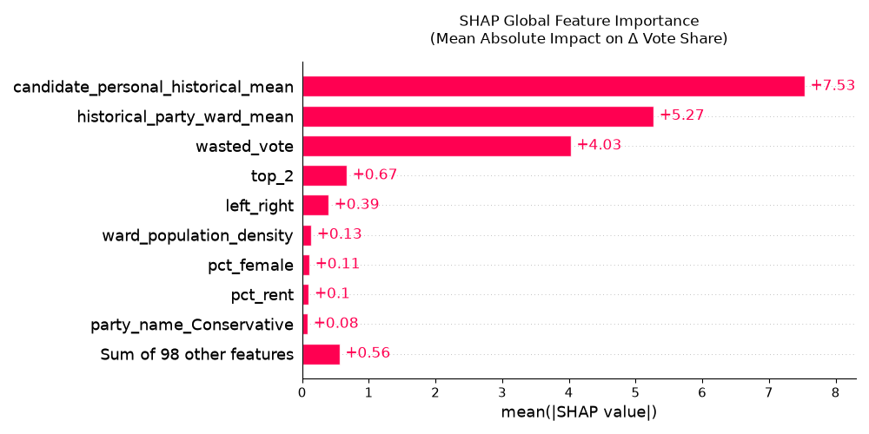

Figure 1: SHAP Global Feature Importance Analysis Bar Chart

Feature Impact Heterogeneity & Nonlinear Dynamics (SHAP Summary Plot)
The complex, non-linear strategic interactions captured by the ensemble are visualized via the SHAP Partial Dependence and Interaction Scatter Plot in Figure 2 [13] [27]. This plot isolates how the localized competitiveness of a ward, modelled by the engineered $top_2$ variable, dynamically impacts the model's forecast results and simultaneously displays how it interacts with a candidate's personal electoral footprint (shown by $candidates_personal_historical_mean$). Each point on the graph represents an individual candidate in a predicted election result. The x-axis plots the distance (in percentage points) in vote share between the first and second place candidates for that ward ($top_2$) in the previous election cycle. The colour of the points displays the candidate’s personal mean in vote share (with red dots displaying candidates with a high mean above 40% and blue for a mean below 10%). A grey density histogram along the bottom margin highlights that a massive portion of the municipal training data sits directly within highly competitive thresholds below 15%.
The distribution of the data points exposes a highly sophisticated, threshold-driven voter coordination mechanism that directly supports the Duvergerian assumptions of rational voter behaviour established in literature [26]. In extremely marginal wards where the difference in vote share between the top two candidates approaches zero ($top_{2}≈0$) the SHAP value peaks at 10% to 13%, especially for popular incumbent candidate who have performed well in previous elections. In safer seats where the difference between the top two candidates moves greater than 15% the impact on vote share then decreases to around zero for most candidates in non-competitive seats can even go down to -8% when the difference reaches 60%, even for popular candidates. This shows that in non-competitive, safe seats, the "tactical squeeze" takes over [26]. The model heavily penalizes even historically strong candidates because the lack of competition in a safe seat suppresses the strategic urgency to mobilize, leading to a downward correction of predicted margins. The empirical documentation of this non-linear, interactive relationship provides decisive validation for hypothesis $H_{2}$, showing that local structural coordination proxies are fundamental for resolving sub-national voting shifts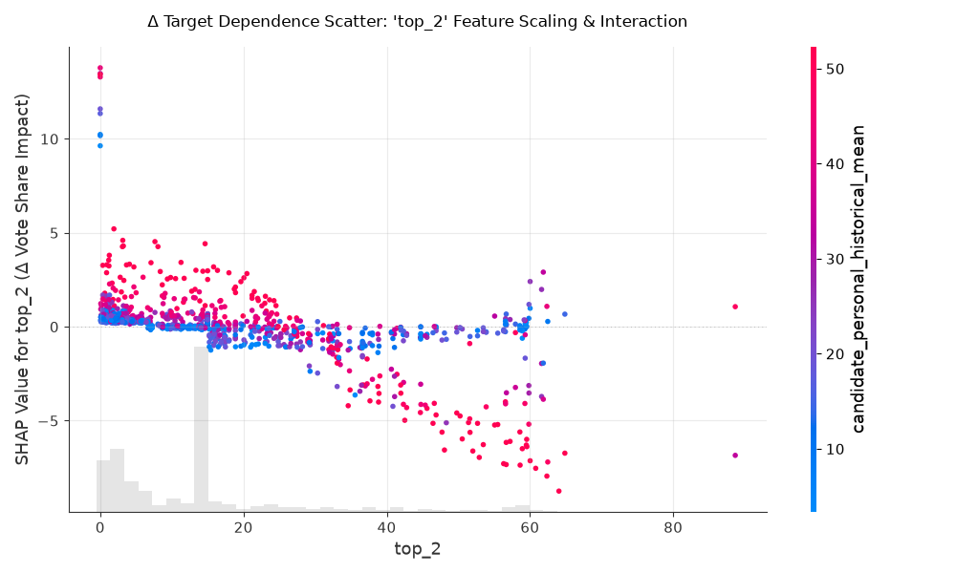

Figure 2: SHAP Top_2 Feature Scaling & Interaction

Spatial Explainability & Ward-Level Micro-Lookup (GeoVisX Integration)
Although the global error metrics and SHAP scatter distribution confirm that the tree-based ensemble framework generalises effectively across the full 6,008 historical rows, analysing electoral trends purely at the macro level risks obscuring critical spatial variation. Forcing high-level national polling aggregates or regional smoothing functions to dictate neighbourhood outcomes introduces a severe Ecological Fallacy [2]. To resolve this spatial research gap, this project implements a post-hoc geographic explainability pipeline utilizing the GeoVisX framework [13]. This pipeline bridges the gap between localized machine learning arrays and physical geographic coordinates, mapping complex mathematical game-theory attributions directly into explicit spatial boundaries.
The engine operates via an interactive command-line lookup interface designed to pull localized data directly out of the TreeExplainer iteration loop [27]. When an operator enters a specific Office for National Statistics (ONS) ward code (e.g., wd_code), the script queries the relational SQL database, isolates the target high-dimensional feature vector, and computes the exact directional SHAP impact for that micro-geographic cell. Rather than outputting a flat text list, the GeoVisX framework joins these localized coordinate vectors to spatial boundary files (Shapefiles or GeoJSON layers) matching a standardized coordinate reference system (CRS). This programmatic join transforms abstract numeric feature weights into discrete spatial boundaries.
Once the rendering pipeline executes, the system generates regional heatmaps exported as localized .png visualizations. Instead of standard electoral choropleths that merely map winning parties, these outputs shade individual ward shapes by the absolute magnitude of specific feature impacts—such as the localized pull of the engineered wasted_vote or top_2 tactical features. This explainability infrastructure fully delivers on Objective 3 (Explainable AI Auditing) by ensuring the machine learning pipeline's decision pathways are completely transparent, reproducible, and geovisually auditable.

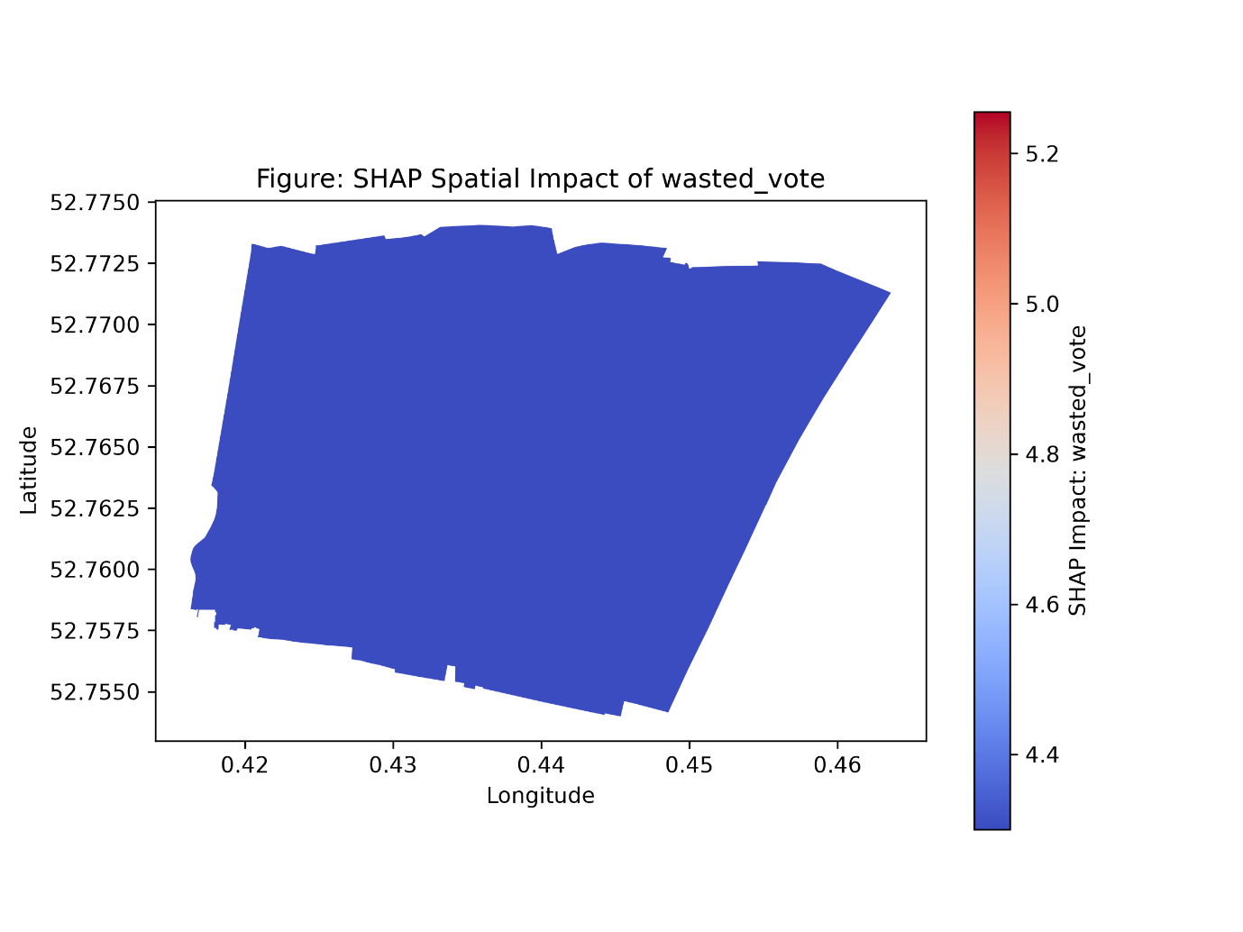

Figure 3: wasted_vote

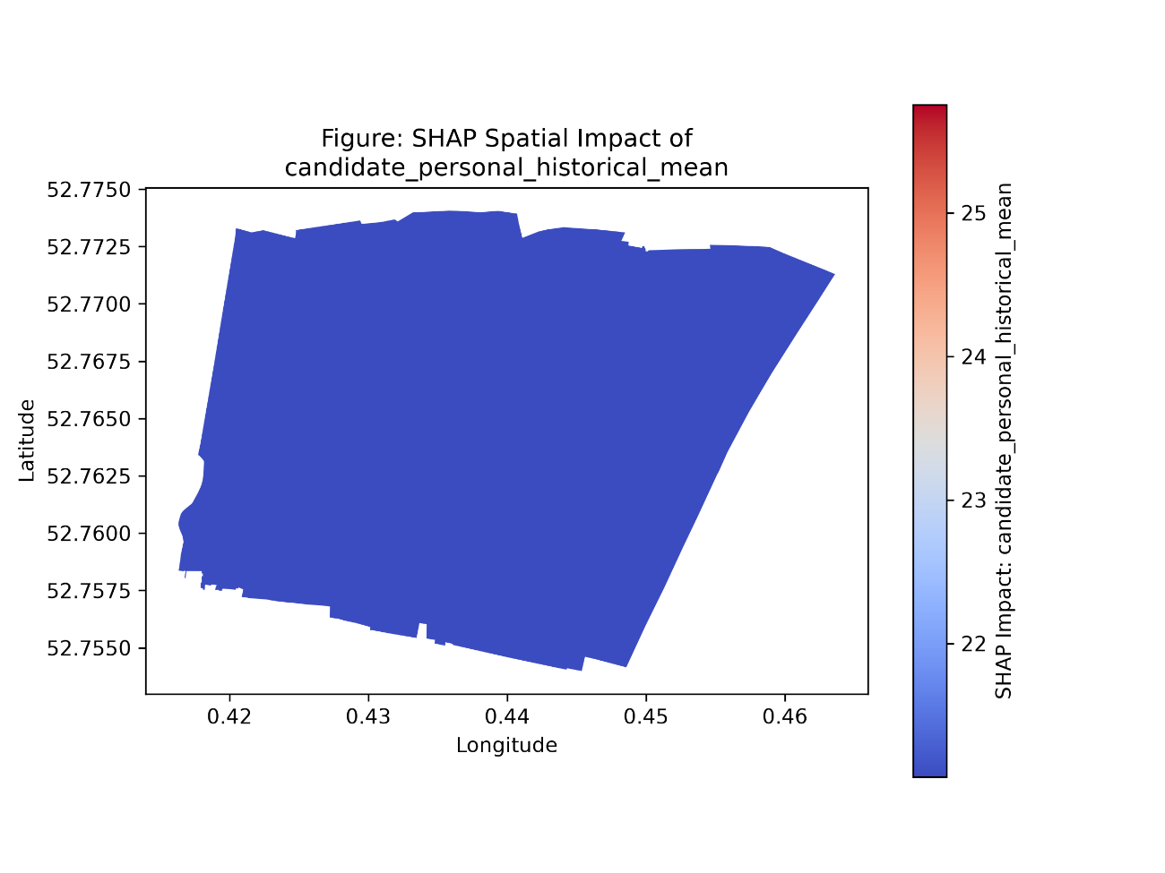

Figure 4: candidate_personal_historical_mean

The boundary maps generated by the GeoVisX framework in Figure 3 and Figure 4 display direct spatial confirmation of the model's high-density non-linear mechanics. Figure 3 shows the constant downward pull from the engineered $wasted_vote$ variable, with the SHAP features for this ward tightly constrained to the values between 4.3% and 5.3%. This relatively narrow, stable variance demonstrates that the ensemble treats the strategic suppression of uncompetitive candidates as a systemic structural rule across the geographic landscape rather than an erratic regional exception, validating the core premise of hypothesis $H_{2}$. The visual footprint of the $candidates_personal_historical_mean$ in Figure 4 shows the opposite by exposing the deep spatial distribute of the model’s primary prediction engine. The variable has a much broader, and highly dynamic scale, peaking above 25% along county council boundaries and below 22% in adjacent divisions. This sharp variation proves that the non-linear pipeline successfully adapts to hyper-local incumbency buffers.
Figure SEQ Figure \* ARABIC 1: A figure containing UoY logo and its caption

Conclusion

Synthesis of Findings & Research Question Resolution
This study set out to evaluate the extent to which non-linear tree-based machine learning algorithms (Random Forest and XGBoost) could outperform traditional linear statistical frameworks in predicting continuous candidate vote shares across UK local council wards. Because of the non-linear model’s $RMSE$ and $R^{2}$ values of 5.03% and 79.29%, this study has shown that non-linear tree-based machine learning algorithms cannot yield a significantly lower Root Mean Squared Error (RMSE) than a traditional linear Logistic Regression baseline when forecasting continuous candidate vote shares in local ward elections. The model’s $RMSE$ of 5.03% shows that the algorithm stays within 5.03% of the correct vote share during training, this underperforms the linear models’ $RMSE$ value of 4.11% by 0.92%. The non-linear algorithm’s $R^{2}$ of 0.7929 shows that the model accounts for 79.29% of the data, underperforming the linear models’ $R^{2}$ of 86.19% by 6.90%. Because the linear baseline achieved a lower global error margin on continuous predictions, formal statistical hypothesis $H1$ is rejected on pure global $RMSE$ terms.
The performance comparison has also revealed a critical theoretical finding. Due to the sparsity of data when unrepresentative national level surveys are used in traditional linear downscaling models like Multilevel Regression and Poststratification (MRP) there is an error drift of 7%[3]. In this project, the linear baseline had a low error of 4.11%, this is due to the feature engineering pipeline supplied dense localised anchoring vectors like the $candidate_personal_historical_mean$ and $historical_party_ward_mean$. Because a candidate's past performance acts as a continuous, near-linear predictor of future returns, Ordinary Least Squares (OLS) regression fits this global historical baseline smoothly across uncompetitive wards.
The study has also found that Hypothesis $H2$ can be formally accepted. The inclusion of engineered tactical proxies—specifically the $wasted_vote$ flag (+4.03 mean absolute SHAP impact) and $top_2$ marginal distance—proved to be the third most influential feature group globally. The linear baseline is unable to model non-linear step-functions, even though it achieves a lower global error on uniform seats. As demonstrated through the SHAP interaction scatter analysis, only the non-linear ensemble successfully isolated the sharp "tactical squeeze" that suppresses uncompetitive candidates in safe seats while accelerating mobilization in marginal wards ($top_2 ≈ 0$). Thus, while linear models fit continuous historical trends efficiently, non-linear ensembles remain essential for capturing non-linear voter coordination mechanics.

Theoretical & Methodological Contributions
This project makes two significant contributions to political methodology and spatial data science. First, it has shown that by uniting the granular data from Census Output Areas from the Office for National Statistics (ONS) with localized historical returns and time-variant polling vectors sub-national council divisions do not have to be ‘data deserts’. The proposed pipeline establishes a high-density tabular matrix that models ward-level outcomes without relying on expensive, unrepresentative national survey aggregates.
Second, the study provides direct empirical validation for Duvergerian theories of rational voter behaviour under First Past the Post (FPTP) systems [26]. The SHAP dependence interaction analysis (top_2 vs. candidate history) shown in Figure 2 gives empirical evidence that under FPTP rational voters vote tactically. In marginal seats ( $top_2≈0$), voter mobilisation increases sharply, whereas in safer seats ( $top_2>15\%$), tactical voting increases as people avoid “wasting their vote”, decreasing vote shares for third party candidates. Furthermore, by combining post-hoc TreeSHAP attributions with the GeoVisX spatial framework [13], this study overcomes the Ecological Fallacy [2]. While linear models might beat trees on global RMSE, only non-linear models combined with spatial SHAP rendering allow researchers to visually audit and explain localized step-functions across geographical ward boundaries.

Practical Implications & Real-World Impact
This predictive framework can benefit both local government administrators and political party campaign strategists. For local authorities, granular ward-level vote share projections provide early intelligence regarding impending council administration shifts and political turnover. Anticipating these shifts allows public administrators to prepare for local manifesto implementations, plan long-term infrastructure and housing budgets, and manage governance transitions smoothly during municipal election cycles.
Local political parties can use the data-driven framework provided by this model for resource allocation. Campaign managers can use the model to identify localised top_2 competitiveness margins and wasted_vote compression flags, which will help optimise limited financial budgets and volunteer deployment. Rather than sending resources to non-competitive seats, campaign managers can deploy doorstep canvassing teams and leafleteers to true marginal seats where strategic voting thresholds are active.

Critical Limitations of the Study
Despite this model’s predictive capabilities and spatial transparency, two key limitations must be acknowledged. First, tree-based mathematical algorithms like Random Forest and XGBoost cannot extrapolate numeric predictions outside the range of its historic training data (2016 – 2026). This means that if there are any sudden unprecedented surges in a party or candidates’ popularity, that breaks all historical vote share boundaries, tree ensembles will inherently under-predict the magnitude of that surge.
Second, when using Census data from the ONS there will always be a temporal lag. The census is only a snapshot of the country’s demographics made once every 10 years. This static demographic vector cannot reflect rapid real-time neighbourhood changes, such as gentrification or new housing developments. Furthermore, periodic boundary reviews by the Local Government Boundary Commission for England require ongoing spatial harmonization via Output Area dissolving to prevent variable misalignment and data leakage across changing ward layouts.

Future Research Directions
Further research can be conducted to extend this project in three directions. First, dynamic local sentiment & Natural Language Processing (NLP) could be incorporated into the pipeline. This would allow the use of local news sentiment data using NLP transformers (e.g., BERT) to capture campaign dynamics in real time. Second, the model could be expanded beyond the English single-member FPTP system to multi-member systems. The model could be expanded to include other multi-member ward systems, like Scotland’s Additional Members System (AMS) [20] and the Single Transferable Vote (STV) in Northern Ireland [20]. Finally, implementing automated Bayesian optimization pipelines (e.g. Optuna) will enable continuous, automated hyperparameter re-tuning as new election returns are ingested into the database.

Bibliography
[1] Keren Tenenboim-Weinblatt , Christian Baden , Tali Aharoni , Maximilian Overbeck, Affective forecasting in elections: A socio-communicative perspective
[2] S. Piantadosi, D. P. Byar, and S. B. Green, "The ecological fallacy," Am. J. Epidemiol., vol. 127, no. 5, pp. 893–904, May 1988, doi: 10.1093/oxfordjournals.aje.a114892.
[3] B. E. Lauderdale, D. Bailey, J. Blumenau, and D. Rivers, "Model-based pre-election polling for national and sub-national outcomes in the US and UK," Int. J. Forecast., vol. 36, pp. 399–413, 2020, doi: 10.1016/j.ijforecast.2019.05.012.
[4] H. Ramm S A, A. S. Nair, and B. U. Maheshwari, "Election analysis using data science," IOSR J. Comput. Eng. (IOSR-JCE), vol. 27, no. 3, ser. 1, pp. 1–8, May–Jun. 2025, doi: 10.9790/0661-2703010108.
[5] M. Tsai, Y. Wang, M. Kwak, and N. Rigole, “A Machine Learning Based Strategy for Election Result Prediction”, International Conference on Computational Science and Computational Intelligence (CSCI), pp. 1408-1410 2019, DOI 10.1109/CSCI49370.2019.00263.
[6] Matthew K. Buttice, Benjamin Highton, “How Does Multilevel Regression and Poststratification Perform with Conventional National Surveys?”
[7] J. M. Montgomery, F. M. Hollenbach, and M. D. Ward, "Improving predictions using ensemble Bayesian model averaging," Polit. Anal., vol. 20, no. 3, pp. 271–291, Summer 2012, doi: 10.1093/pan/mps002.
[8] Data Protection Act 2018, c. 12. London, UK: The Stationery Office, 2018. [Online]. Available: https://www.legislation.gov.uk/ukpga/2018/12/contents.
[9] MICHAEL F. SCHOBER, JOSH PASEK, LAUREN GUGGENHEIM, CLIFF LAMPE ,FREDERICK G. CONRAD “SOCIAL MEDIA ANALYSES FOR SOCIAL MEASUREMENT”
[10] Jonathan Mellon and Christopher Prosser, “Twitter and Facebook are not representative of the general population: Political attitudes and demographics of British social media users”.
[11] AMIN MAHMOUDI, DARIUSZ JEMIELNIAK, AND LEON CIECHANOWSKI ,“Echo Chambers in Online Social Networks: A Systematic Literature Review”
[12] Jaiswal and Samikannu (2017), “Application of Random Forest Algorithm on Feature Subset Selection and Classification and Regression”
[13] Yuxuan, Zhang (2021), “Geovisual Analytics of U.S. Election Data Empowered by Explainable Artificial Intelligence”
[14] Nitesh Keshavelal Poona, Adriaan van Niekerk, Ryan Leslie Nadel, and Riyad Ismail (2016), “Random Forest (RF) Wrappers for Waveband Selection and Classification of Hyperspectral Data”
[15] M. Saunders, P. Lewis, and A. Thornhill, Research Methods for Business Students, 8th ed. Harlow, U.K.: Pearson, 2019.
[16] Office of National Statistics website (https://www.nomisweb.co.uk/)
[17] Local government reorganisation website (https://www.gov.uk/government/collections/local-government-reorganisation-policy-and-programme-updates)
[18] Ingrid Mauerer and Annemarie Walter (2024), “Rational voting behaviour accounting for heterogeneous ballots in British elections”
[19] ONS Open Geography Portal (https://geoportal.statistics.gov.uk/)
[20] Toby Cooper, Neil McNaughton, Pearson Edexcel A Level UK Government and Politics Seventh Edition, chapt 4
[21] Lauri Rapeli, “Comparing Local National and EU Knowledge The Ignorant Public Reassessed”.
[22] Johnston, R., and Pattie, C. (2014). Money and Electoral Politics: Local Parties and Funding in British Elections. Routledge.
[23] Rodden, J. A. (2019). “Why cities lose: The deep roots of the urban-rural political divide.”
[24] The Local Government Boundary Commission for England (https://www.lgbce.org.uk/)
[25] YouGov (https://yougov.com/en-gb/articles/52080-where-do-britons-see-politicians-parties-and-themselves-on-the-left-right-spectrum)
[26] H. Kim and R. C. Fording, "Does tactical voting matter? The political impact of tactical voting in recent British elections," Comp. Polit. Stud., vol. 34, no. 3, pp. 294–311, Apr. 2001
[27] Scott M Lundberg, Su-In Lee (2017), “A Unified Approach to Interpreting Model Predictions”

